A randomised double-blind cross-over trial was carried out to evaluate a new steroid inhaler for the treatment of asthma in adults. The trial plan was to assign patients randomly either to the Standard Inhaler followed by the New Inhaler or vice versa. Each patient measured his peak expiratory flow rate (PEFR in l/min) every evening at 7 pm. The mean PEFR for 14 days was recorded for each inhaler. Using the data pefr.dta,

a. Is there any difference in mean PEFR between the New and Standard inhalers?
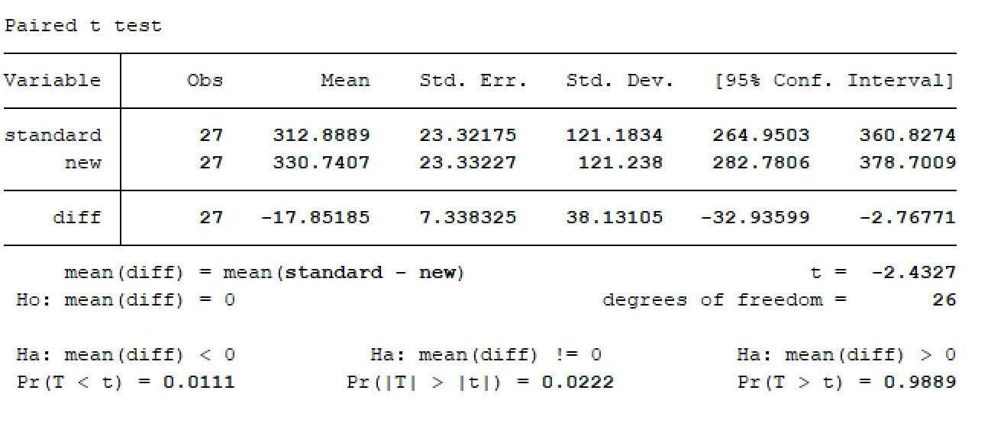

b. Is it possible that any treatment difference in PEFR may depend on which inhaler is given first?
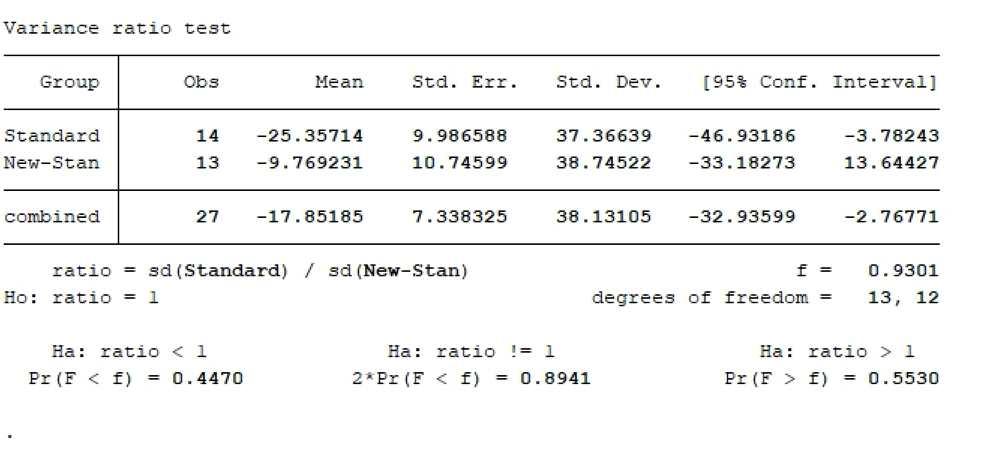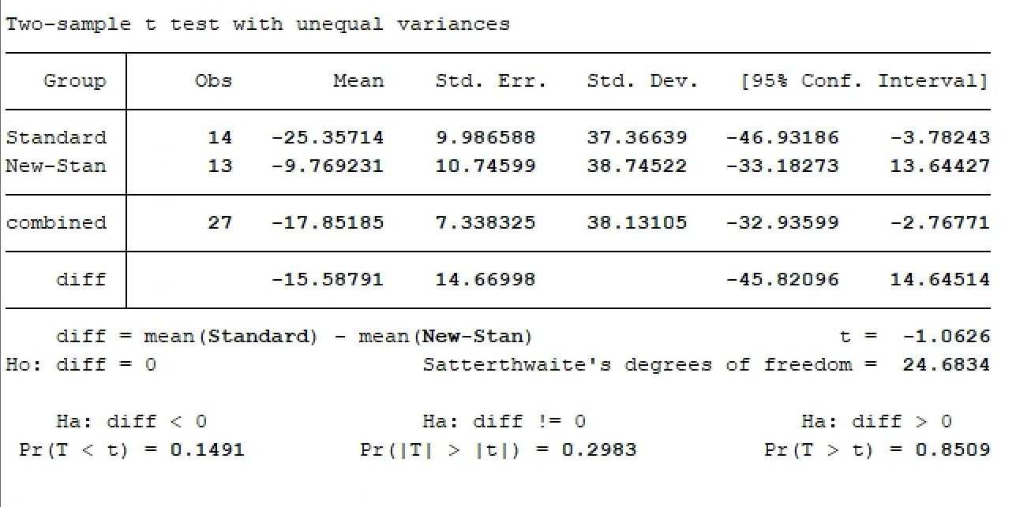
2. The data AF.dta contains information on ventricular rate of 152 cases with lone atrial fibrillation (LAF). LAF is known to be familial in at least 15% of cases, and hence the information on family history (1=Yes, 0=No) was also recorded.

a. Summarize the ventricular rate of cases by family history.
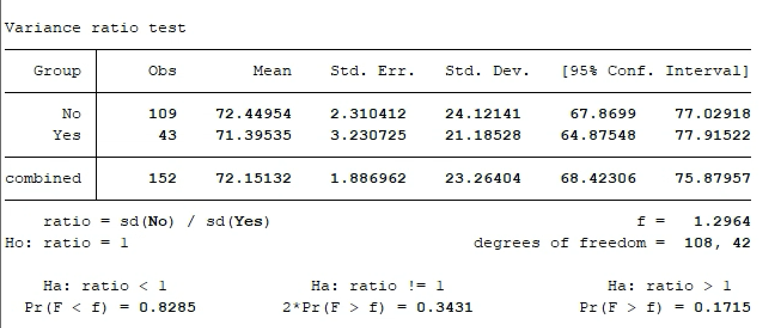
b. Obtain a histogram of ventricular rate by family history. Is it reasonable to assume that the underlying populations are normally distributed?
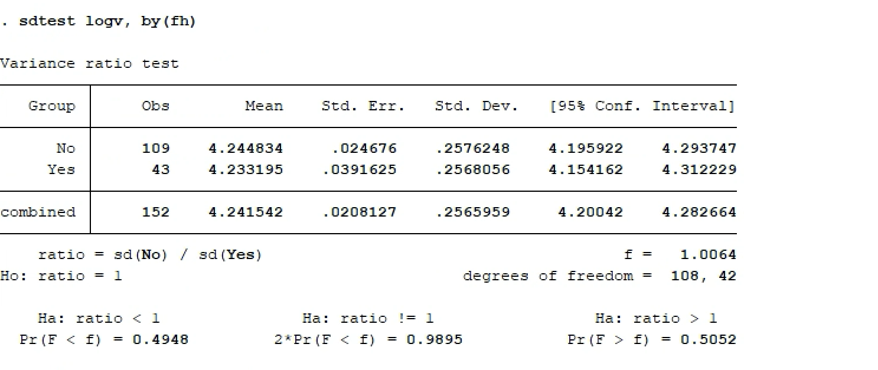
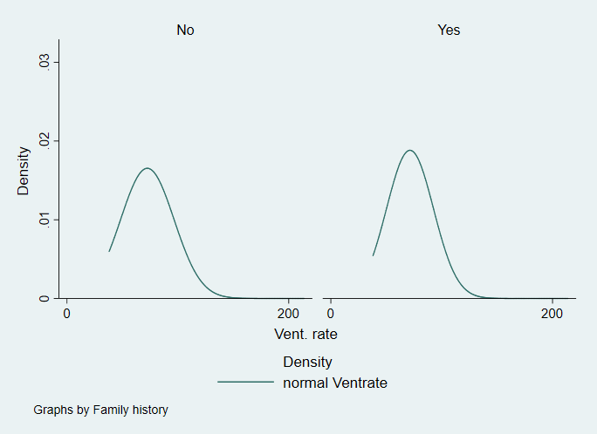
c. Are the assumptions of the t-test valid?
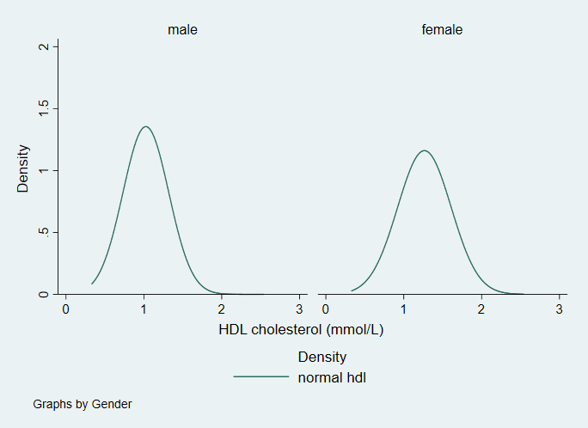
d. By applying log transformation to the data, are the assumptions of the t-test now valid? Calculate the geometric mean for each group and interpret the results of your analysis
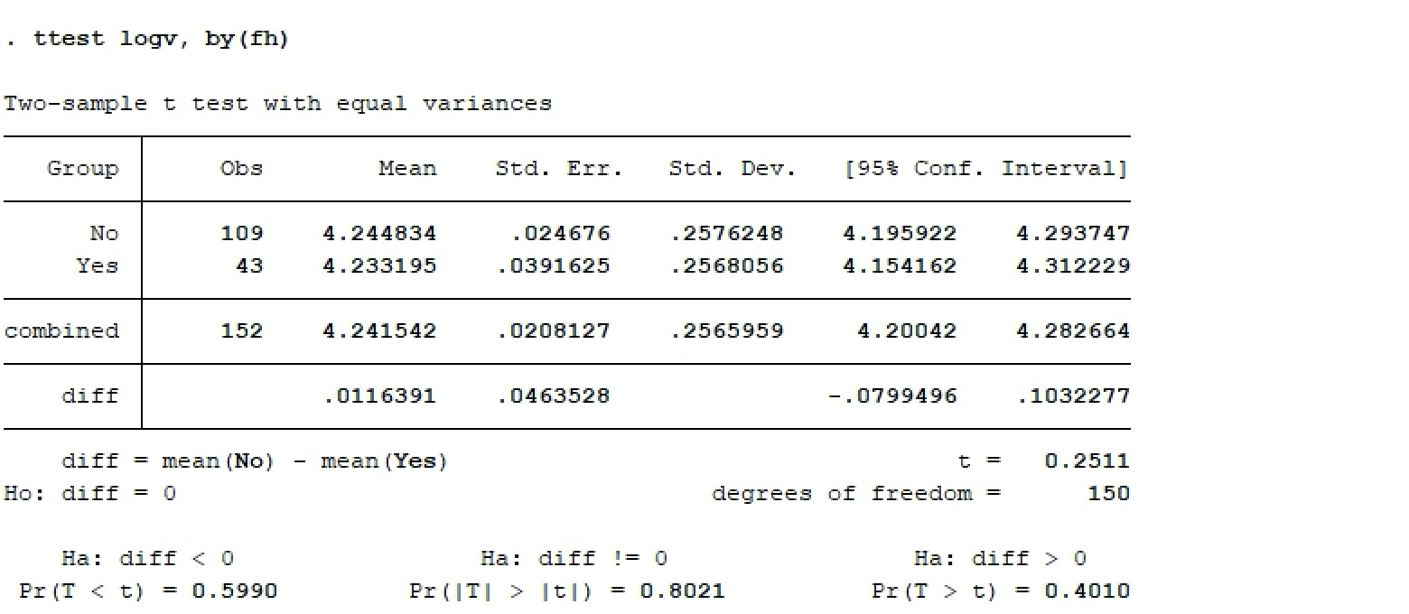
geometric:
